Notes on happiness results.
The PDF for an eleven category Best Possible-Worst Possible Life Satisfaction variable or a four category Living on Income Management Category is given by $p_{k} for k=1,..,K$ where $K$ is the number of categories and $p_{k}≥0$ with $\sum_{k=1}^{11}{p_{k}}=1.$ The CDF is given by $P_{k} for k=1,..,11$ where $P_{k}=\sum_{i=1}^{k}{p_{i}}$ and the Survival Function (the Chance of a higher outcome than $i$) is given by $S_{k}=1-P_{k} for k=1,..,11$.
Since in the continuous world the mean or expected value may be written as the integral of the Survival Function, here we shall use $\sum_{k=1}^{K}{S_{k}}$ , the sum of chances of higher outcomes, as the corresponding categorical mean or expected value of life satisfaction of the representative agent. This construct is dependent on the number of categories, since we need something that is comparable across variables with different numbers of categories we will use a construct which is the expected or average chance of a higher outcome of the representative agent. There are two ways of doing this, we can use an uninformative prior where every category is presumed to have an equal chance of occurring ($\sum_{k=1}^{K}{S_{k}/K}$ referred to as “equal weighted”) or using the actual chance of a category occurring ($\sum_{k=1}^{K}{S_{k}}p_{k}$ referred to as “category weighted”).
When distributions are not symmetric unimodal, The Modal value can be more representative of the population than the expected or average value and a better representative agent (Anderson 2026). Its importance in this regard can be measured by how skewed and peaked a distribution is. Letting $M$ denote the most likely (i.e. modal) category in the distribution, the odds ratio of any category $k$ and the modal category is given by $o_{k}=p_{k}/p_{M}$ and Informity or Peakedness is given by $1-\sum_{k=1}^{K}{p_{k}o_{k}}$, letting $A$ denote the Average or Mean category in the distribution, Left Skewness is measured by the extent to which $P_{A}-P_{M}$ is left skewed.
The extent of change in the distribution of happiness from the initial condition can be measured by Gini’s distributional transvariation which measures the probabilistic difference between two distributions. For distributions A and B with category probabilities $p_{k,A} and p_{k,B} for k=1,..,K$ it is given by $\frac{\sum_{k=1}^{K}{\left|p_{k,A}-p_{k,B}\right|}}{2}=1-\sum_{k=1}^{K}{min\left(p_{k,A},p_{k,B}\right)}$. A value of $0$ means the distributions are identical, a value of $1$ means they are completely segmented.
In the context of a multidimensional study where Best Possible-Worst Possible Life Satisfaction and Living on Income management are considered jointly with $K$ life satisfaction outcomes indexed from worst to best as $k=1,..,K$ and $J$ income management outcomes indexed from worst to best as $j=1,..,J$, the PDF is given by $p_{k,j} for k=1,..,K and j=1,..,J$, where $p_{k,j}≥0 with \sum_{k=1}^{K}{\sum_{j=1}^{J}{p_{k,j}}=1}$. The CDF is given by $P_{k.j}=\sum_{i=1}^{k}{\sum_{h=1}^{j}{p_{i,h}}}$ and the Survival Function is given by $S_{k,j}=1-P_{k.j}$. Expected outcome levels are given by $\sum_{k=1}^{K}{\sum_{j=1}^{J}{p_{k,j}S_{k,j}}}$ for the weighted version and $\sum_{k=1}^{K}{\sum_{j=1}^{J}{S_{k,j}/KJ}}$ for the equally weighted version.

Table 1. Expected chance of a higher wellbeing outcome (category weighted)
 | 2010 2015 2020 2025
Brazil | 0.42671838 0.42983662 0.42434067 0.42721736
Canada | 0.39678265 0.39337507 0.40978957 0.41378919
China | 0.41575538 0.41546722 0.43139496 0.43218587
India | 0.42241212 0.42507342 0.42258696 0.43504237
Russia | 0.41846350 0.42461605 0.42534204 0.43021186
Sweden | 0.38560844 0.39090592 0.39547486 0.39433848
United Kingdom | 0.41379405 0.41009621 0.39981887 0.41862341
United States | 0.41792692 0.42033992 0.40917367 0.39887667
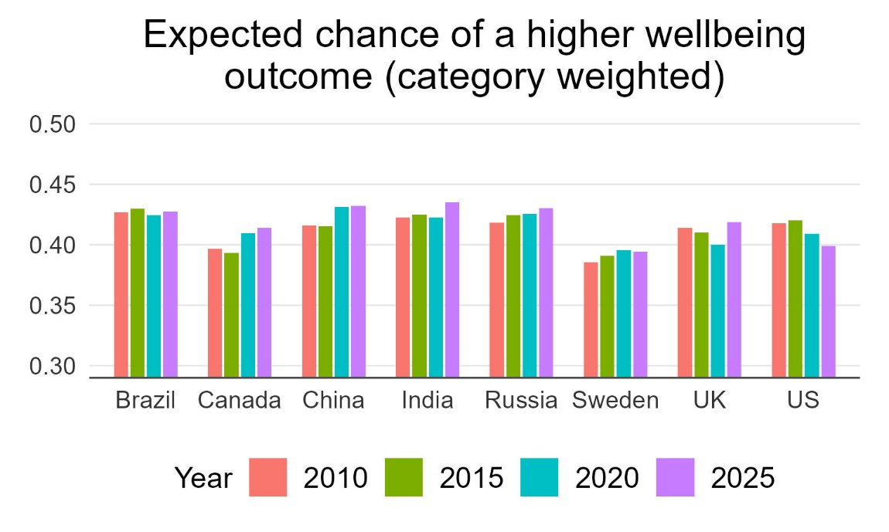

Table 2. Expected chance of higher Wellbeing outcome (equally weighted)
 | 2010 2015 2020 2025
Brazil | 0.61916939 0.58309730 0.58052469 0.59770864
Canada | 0.69920869 0.67594562 0.65539744 0.63609145
China | 0.43627950 0.47721302 0.52955565 0.59514511
India | 0.47260983 0.39065180 0.28579058 0.40583973
Russia | 0.49369717 0.54179894 0.50052876 0.54481305
Sweden | 0.67976245 0.67292787 0.67089995 0.66563326
United Kingdom | 0.63823612 0.60003651 0.62995514 0.61807207
United States | 0.66886481 0.63509286 0.66203956 0.63508708

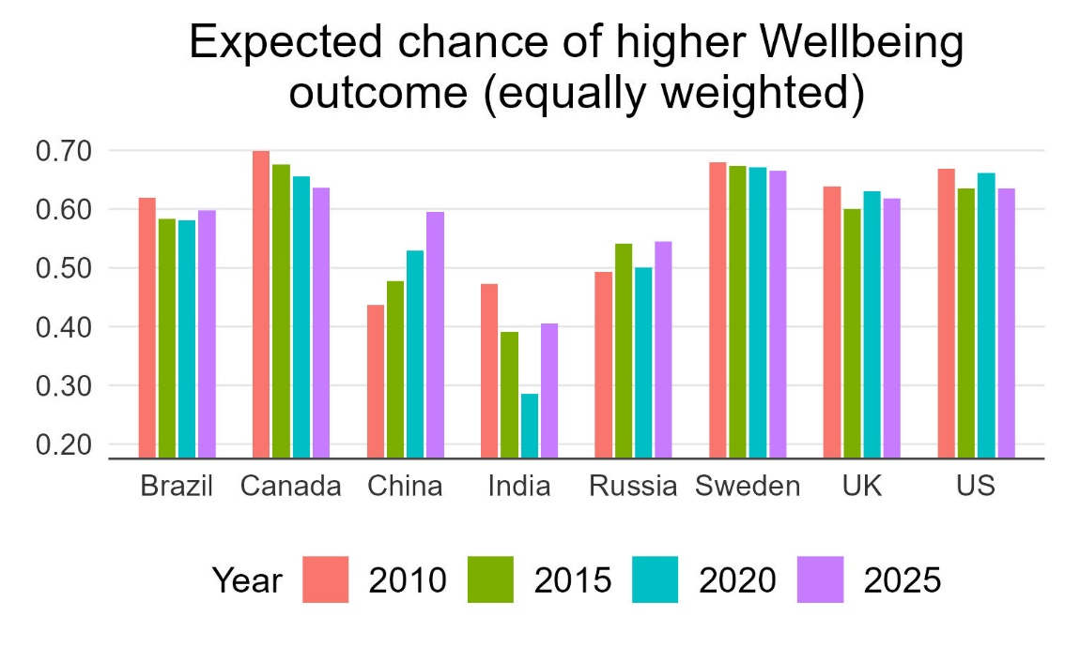
Wellbeing Distributional Difference from 2010
 | 2010 2015 2020 2025
Brazil | 0.00000000 0.11499301 0.16419648 0.11728725
Canada | 0.00000000 0.08697555 0.13032562 0.18363071
China | 0.00000000 0.12371464 0.25703178 0.40055306
India | 0.00000000 0.18746509 0.44698419 0.16757117
Russia | 0.00000000 0.14081929 0.07376934 0.16677575
Sweden | 0.00000000 0.03625449 0.04522613 0.09844105
United Kingdom | 0.00000000 0.13528160 0.13961375 0.09496319
United States | 0.00000000 0.10580534 0.10750209 0.21744716

Wellbeing Peakedness and Skewness.
 | 2010 2015 2020 2025
Brazil Mode  Informity  Expected (weighted)  Expected (average)  Left Skewness (weighted)  Left Skewness (Average) | 9.0000000 6.0000000 8.0000000 6.0000000  0.34014545 0.36534034 0.31042908 0.28607175  7.0000000 6.0000000 6.0000000 7.0000000  5.0000000 5.0000000 5.0000000 5.0000000  -0.38603298 0.0000000 -0.35671343 0.10348361  -0.65470417 -0.22110553 -0.55711423 -0.20389344
Canada Mode  Informity  Expected (weighted)  Expected (average)  Left Skewness (weighted)  Left Skewness (Average) | 9.0000000 9.0000000 9.0000000 9.0000000  0.40537175 0.40950812 0.40078770 0.38517272  8.0000000 7.0000000 7.0000000 7.0000000  4.0000000 4.0000000 5.0000000 5.0000000  -0.34716599 -0.57680570 0.51545364 -0.50000000  -0.68825911 -0.76093591 -0.70289133 -0.73153693
China Mode  Informity  Expected (weighted)  Expected (average)  Left Skewness (weighted)  Left Skewness (Average) | 6.0000000 6.0000000 6.0000000 9.0000000  0.45526232 0.48555416 0.40238579 0.27489204  5.0000000 5.0000000 6.0000000 7.0000000  5.0000000 5.0000000 5.0000000 5.0000000  -0.30930346 -0.32863626 0.0000000 -0.35855915  -0.30930346 -0.32863626 -0.2295964 -0.63417052
India Mode  Informity  Expected (weighted)  Expected (average)  Left Skewness (weighted)  Left Skewness (Average) | 6.0000000 6.0000000 1.0000000 6.0000000  0.41816505 0.39815406 0.45157782 0.47533535  5.0000000 4.0000000 3.0000000 4.0000000  5.0000000 5.0000000 5.0000000 5.0000000  -0.26670066 -0.43901617 0.18863131 -0.37295640  -0.26670066 -0.24898922 0.37900921 -0.24761580
Russia Mode  Informity  Expected (weighted)  Expected (average)  Left Skewness (weighted)  Left Skewness (Average) | 6.0000000 6.0000000 6.0000000 6.0000000  0.44923555 0.36817889 0.47532349 0.38187644  5.0000000 6.0000000 6.0000000 6.0000000  5.0000000 5.0000000 5.0000000 5.0000000  -0.29608483 0.0000000 0.0000000 0.0000000  -0.29608483 -0.23862434 -0.28458662 -0.22580645
Sweden Mode  Informity  Expected (weighted)  Expected (average)  Left Skewness (weighted)  Left Skewness (Average) | 9.0000000 9.0000000 9.0000000 9.0000000  0.39457661 0.39236424 0.39882941 0.34364777  7.0000000 7.0000000 7.0000000 7.0000000  4.0000000 4.0000000 4.0000000 4.0000000  -0.60603015 -0.59378134 -0.57587940 -0.58876630  -0.77688442 -0.76930792 -0.75879397 -0.77331996
United Kingdom Mode  Informity  Expected (weighted)  Expected (average)  Left Skewness (weighted)  Left Skewness (Average) | 9.0000000 8.0000000 8.0000000 9.0000000  0.36345268 0.29492774 0.35402689 0.32872755  7.0000000 7.0000000 7.0000000 7.0000000  5.0000000 5.0000000 4.0000000 5.0000000  -0.49433574 -0.25502008 -0.31017120 -0.47987928  -0.72914521 -0.57429719 -0.56394763 -0.71327968
United States Mode  Informity  Expected (weighted)  Expected (average)  Left Skewness (weighted)  Left Skewness (Average) | 9.0000000 9.0000000 9.0000000 9.0000000  0.39541589 0.40494883 0.38089807 0.29597183  7.0000000 7.0000000 7.0000000 7.0000000  5.0000000 5.0000000 5.0000000 4.0000000  -0.43523316 -0.45591398 -0.52095808 -0.56970913  -0.61761658 -0.68924731 -0.70758483 -0.84453360

Table 3. Expected chance of a higher income satisfaction (category weighted)
 | 2010 2015 2020 2025
Brazil | 0.31268222 0.33167849 0.34101068 0.33968208
Canada | 0.30422253 0.29312349 0.29893172 0.31486428
China | 0.30298218 0.30221113 0.29390872 0.29335897
India | 0.36160680 0.36158773 0.36722947 0.35426508
Russia | 0.31852659 0.29983287 0.33978884 0.31433321
Sweden | 0.26031363 0.27876609 0.26735688 0.27233556
United Kingdom | 0.31245565 0.33139889 0.29013365 0.30750701
United States | 0.32189535 0.31405827 0.29357353 0.28957786

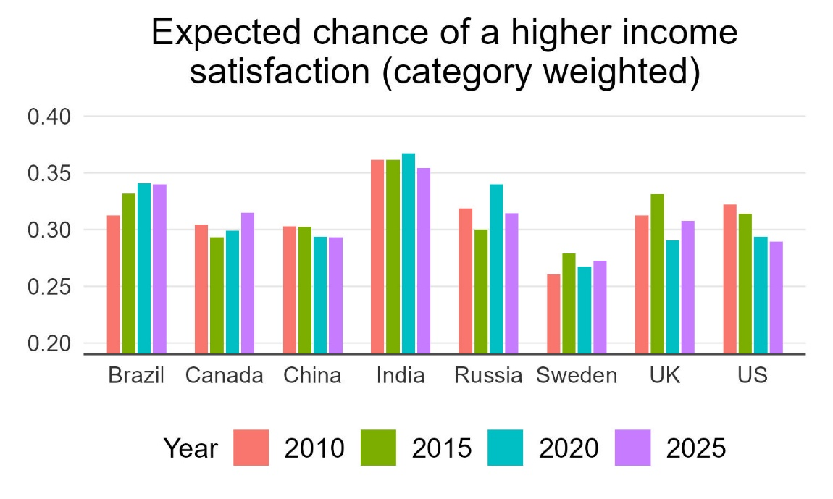
Table 4. Expected chance of higher income Satisfaction (equally weighted)
 | 2010 2015 2020 2025
Brazil | 0.45465567 0.41155779 0.46442886 0.45312500
Canada | 0.57970648 0.59435402 0.58673978 0.56437126
China | 0.42498782 0.42046812 0.45149477 0.53899537
India | 0.39095699 0.36649259 0.31513973 0.38266349
Russia | 0.47654976 0.53240741 0.49423556 0.56300403
Sweden | 0.63216080 0.61183551 0.62487437 0.61860582
United Kingdom | 0.54891864 0.53187751 0.59994965 0.57243461
United States | 0.55181347 0.56424731 0.59406188 0.59854564

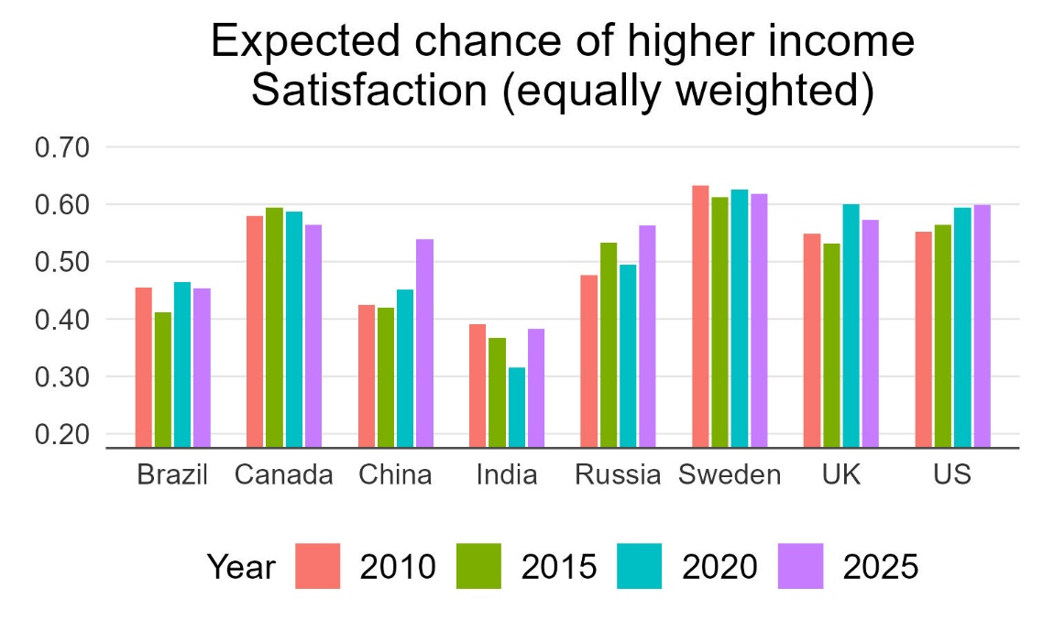
Income satisfaction Distributional Difference from 2010
 | 2010 2015 2020 2025
Brazil | 0.00000000 0.10083980 0.10110813 0.09034480
Canada | 0.00000000 0.03514812 0.02626937 0.03491802
China | 0.00000000 0.00828696 0.05874185 0.20781140
India | 0.00000000 0.06108703 0.15837432 0.08114384
Russia | 0.00000000 0.10768965 0.10199159 0.22789603
Sweden | 0.00000000 0.05837916 0.02110553 0.03831898
United Kingdom | 0.00000000 0.06667246 0.14842932 0.07243357
United States | 0.00000000 0.04507215 0.09712699 0.08282360

Income Satisfaction Peakedness and Skewness.
 | 2010 2015 2020 2025
Brazil Mode  Informity  Expected (weighted)  Expected (average)  Left Skewness (weighted)  Left Skewness (Average) | 3.0000000 3.0000000 3.0000000 3.0000000  0.30655427 0.29183975 0.29791441 0.31221852  2.0000000 2.0000000 2.0000000 2.0000000  1.0000000 1.0000000 1.0000000 1.0000000  -0.54025218 -0.47537688 -0.45290581 -0.46618852  -0.76042677 -0.76080402 -0.65931864 -0.67008197
Canada Mode  Informity  Expected (weighted)  Expected (average)  Left Skewness (weighted)  Left Skewness (Average) | 4.0000000 4.0000000 4.0000000 4.0000000  0.2324280 0.2411955 0.2502919 0.2579761  2.0000000 2.0000000 2.0000000 2.0000000  1.0000000 1.0000000 1.0000000 1.0000000  -0.8562753 -0.87283825 -0.85742772 -0.82135729  -0.9524291 -0.95930824 -0.95314058 -0.93712575
China Mode  Informity  Expected (weighted)  Expected (average)  Left Skewness (weighted)  Left Skewness (Average) | 3.0000000 3.0000000 3.0000000 3.0000000  0.28851786 0.28516013 0.29294837 0.24572283  2.0000000 2.0000000 2.0000000 2.0000000  1.0000000 1.0000000 1.0000000 1.0000000  -0.55382367 -0.55337951 -0.58295964 -0.54791804  -0.81880175 -0.82469549 -0.80687593 -0.65730337
India Mode  Informity  Expected (weighted)  Expected (average)  Left Skewness (weighted)  Left Skewness (Average) | 3.0000000 3.0000000 1.0000000 3.0000000  0.1970738 0.2349951 0.1476159 0.2832869  2.0000000 1.0000000 1.0000000 2.0000000  1.0000000 1.0000000 1.0000000 1.0000000  -0.34472208 -0.65229111 0.0000000 -0.40667575  -0.66071732 -0.65229111 0.0000000 -0.67949591
Russia Mode  Informity  Expected (weighted)  Expected (average)  Left Skewness (weighted)  Left Skewness (Average) | 3.0000000 3.0000000 3.0000000 4.0000000  0.29518562 0.2523402 0.2240880 0.1703538  2.0000000 2.0000000 2.0000000 2.0000000  1.0000000 1.0000000 1.0000000 1.0000000  -0.51495378 -0.53544974 -0.41296219 -0.84072581  -0.73219141 -0.67354497 -0.64416286 -0.96370968
Sweden Mode  Informity  Expected (weighted)  Expected (average)  Left Skewness (weighted)  Left Skewness (Average) | 4.0000000 4.0000000 4.0000000 4.0000000  0.2037131 0.1860878 0.1990315 0.1922368  3.0000000 2.0000000 2.0000000 2.0000000  1.0000000 1.0000000 1.0000000 1.0000000  -0.60201005 -0.92176530 -0.93467337 -0.93079238  -0.98592965 -0.98194584 -0.98391960 -0.97993982
United Kingdom Mode  Informity  Expected (weighted)  Expected (average)  Left Skewness (weighted)  Left Skewness (Average) | 3.0000000 4.0000000 4.0000000 4.0000000  0.17785300 0.14758017 0.22239821 0.16990009  2.0000000 2.0000000 2.0000000 2.0000000  1.0000000 1.0000000 1.0000000 1.0000000  -0.45623069 -0.78514056 -0.88620342 -0.86116700  -0.56539650 -0.94678715 -0.97381672 -0.96478873
United States Mode  Informity  Expected (weighted)  Expected (average)  Left Skewness (weighted)  Left Skewness (Average) | 4.0000000 4.0000000 4.0000000 4.0000000  0.2097886 0.2432131 0.2464870 0.2113125  2.0000000 2.0000000 2.0000000 2.0000000  1.0000000 1.0000000 1.0000000 1.0000000  -0.81761658 -0.83118280 -0.86826347 -0.89368104  -0.93886010 -0.93440860 -0.96007984 -0.96690070

Table 5. Multidimensional Analysis.
 |  | 2010 | 2015 | 2020 | 2025
Brazil | Expected HO (weighted)  Expected HO (unweighted)  Modal Wellbeing (Joint)  Informity | 0.57203647  0.78209980  9,3  0.53491756 | 0.57674834  0.74095012  6,3  0.49469128 | 0.56467134  0.76013636  8,3  0.52820170 | 0.57579345  0.76356192  8,3  0.45210322
Canada | Expected HO (weighted)  Expected HO (unweighted)  Modal Wellbeing (Joint)  Informity | 0.52931968  0.85877113  9,4  0.54892204 | 0.50921113  0.85238751  9,4  0.56887251 | 0.51865060  0.84048027  9,4  0.58093965 | 0.52839938  0.82359200  9,4  0.58525436
China | Expected HO (weighted)  Expected HO (unweighted)  Modal Wellbeing (Joint)  Informity | 0.52269472  0.66078384  6,3  0.60050613 | 0.52228415  0.68007076  6,3  0.60350795 | 0.53590299  0.72516646  6,3  0.54191856 | 0.55718593  0.80443730  8,3  0.40922971
India | Expected HO (weighted)  Expected HO (unweighted)  Modal Wellbeing (Joint)  Informity | 0.54673368  0.65805188  6,2  0.51311172 | 0.59835936  0.60412583  6,3  0.57854078 | 0.58433414  0.49122377  1,1  0.63661515 | 0.59437401  0.62044061  6,3  0.61148126
Russia | Expected HO (weighted)  Expected HO (unweighted)  Modal Wellbeing (Joint)  Informity | 0.54989731  0.72308938  6,3  0.62046214 | 0.54471319  0.77406064  6,3  0.53344958 | 0.55716445  0.73107320  6,3  0.59505380 | 0.54759729  0.78538405  8,4  0.48337124
Sweden | Expected HO (weighted)  Expected HO (unweighted)  Modal Wellbeing (Joint)  Informity | 0.50692864  0.87250000  9,4  0.53089763 | 0.52415072  0.86266201  9,4  0.51384200 | 0.52253955  0.86844143  9,4  0.53175527 | 0.52283989  0.86097054  9,4  0.47012540
UK | Expected HO (weighted)  Expected HO (unweighted)  Modal Wellbeing (Joint)  Informity | 0.54334786  0.82279720  9,4  0.46919175 | 0.56526808  0.80257530  9,4  0.41127814 | 0.54111045  0.84177186  9,4  0.46960702 | 0.55859580  0.82729557  9,4  0.50243304
US | Expected HO (weighted)  Expected HO (unweighted)  Modal Wellbeing (Joint)  Informity | 0.53810431  0.83233941  9,4  0.45929119 | 0.52564200  0.81929995  9,4  0.58676592 | 0.52442975  0.84810041  9,4  0.55006996 | 0.50801313  0.83754960  9,4  0.51726608

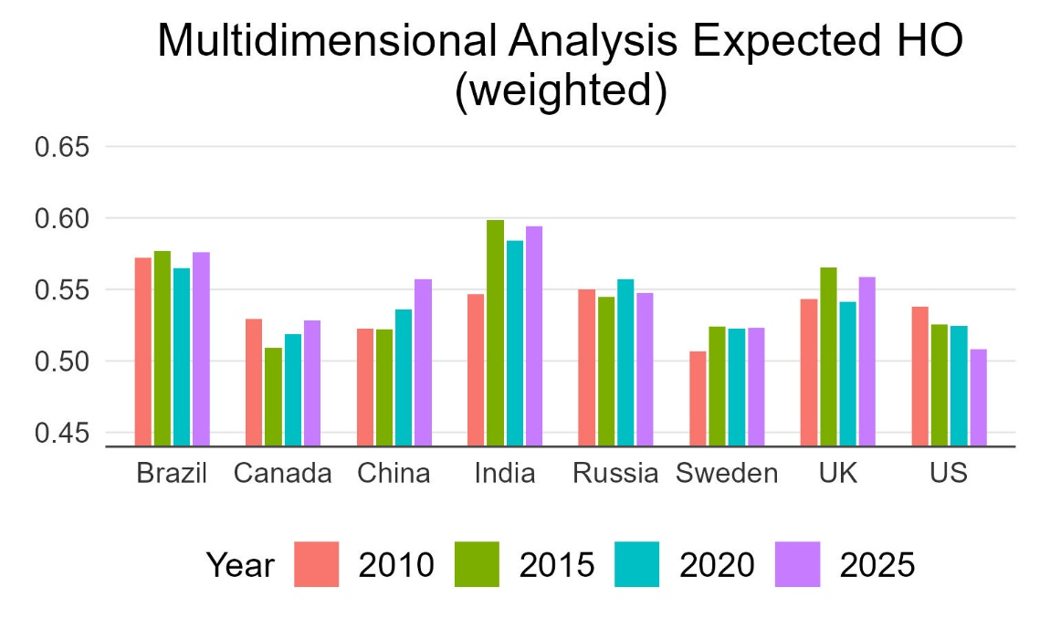

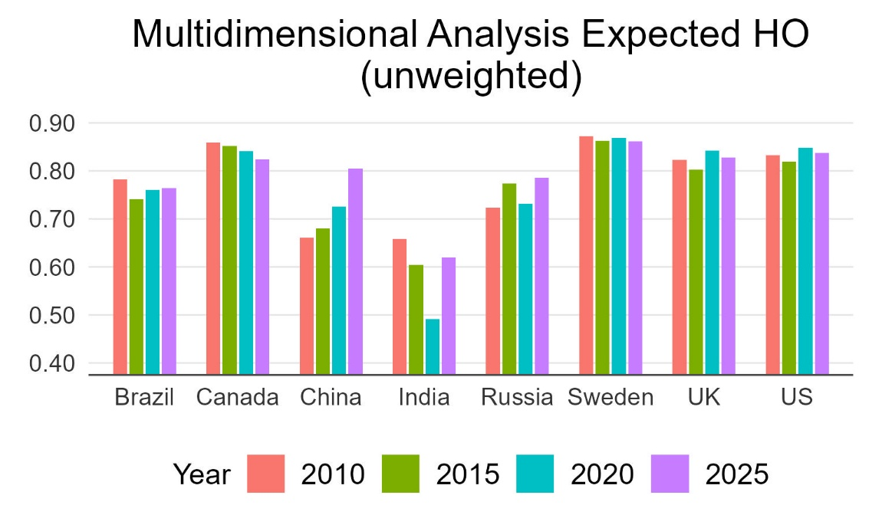
Distributional difference from 2010
 | 2010 2015 2020 2025
Brazil | 0.0 0.16446539 0.21354348 0.16621466
Canada | 0.0 0.13170096 0.14745894 0.18926822
China | 0.0 0.14475726 0.26553274 0.43340247
India | 0.0 0.25950074 0.49353234 0.25502869
Russia | 0.0 0.17110231 0.13333019 0.25520340
Sweden | 0.0 0.08388633 0.09246231 0.12428038
United Kingdom | 0.0 0.19110272 0.20779649 0.14806605
United States | 0.0 0.17416291 0.18527349 0.30422355

Data Definitions.
=====
WP16:
Please imagine a ladder with steps numbered from zero at the bottom to ten at the top. Suppose we say that the top of the ladder represents the best possible life for you, and the bottom of the ladder represents the worst possible life for you. On which step of the ladder would you say you personally feel you stand at this time, assuming that the higher the step the better you feel about your life, and the lower the step the worse you feel about it? Which step comes closest to the way you feel?

0 = Worst possible
10 = Best possible
-1 = (DK)
-2 = (Refused)

======
WP18:
Please imagine a ladder with steps numbered from zero at the bottom to ten at the top. Suppose we say that the top of the ladder represents the best possible life for you, and the bottom of the ladder represents the worst possible life for you. Just your best guess, on which step do you think you will stand in the future, say about five years from now?

0 = Worst possible
10 = Best possible
-1 = (DK)
-2 = (Refused)

====
WP2319:
Which one of these phrases comes closest to your own feelings about your household's income these days?

0 = Finding it very difficult on present income
1 = Finding it difficult on present income
2 = Getting by on present income
3 = Living comfortably on present income
-1 = (DK)
-2 = (Refused)

